Brett Bump
Oglala Lakota College (IT Department)
September 15, 2002

Tutorial: Installing a portable Classroom Cluster with LTSP

Introduction

Most cluster installations require a group of individual computers that are dedicated to only running the software needed to support the cluster. For many small colleges, there is neither the amount of hardware to dedicate to this application, nor the support staff to manage it. This step-by-step guide will instruct you through the process of installing one microcomputer to act as a cluster server for a classroom of computers. This installation in no way changes the operating system or data on the machines in the classroom.

Objectives

This step-by-step guide enables you to install K12LTSP version 2.1.1 and MPICH version 1.2.4. You will be able to demonstrate the power of cluster applications in a common networked classroom setting.

Target Audience

Any individual who wants to know how to install a high performance cluster to demonstrate cluster applications, will find this guide helpful. If you have installed Red Hat 7.2 or 7.3 and are familiar with Linux, you can successfully navigate through this cluster install.

Reference

For complete detailed information of LTSP and MPICH, you should read the information available at the following web address locations:

http://www.ltsp.org
http://www.k12ltsp.org
http://www-unix.mcs.anl.gov/mpi/mpich

- Red Hat Linux LTSP Installation

We begin with what appears to be a generic Red Hat Linux 7.3 installation. For more information about installing or using Red Hat Linux in any situation, visit their web address at: http://www.redhat.com

- Boot the server with the first disc of the K12LTSP distribution. My install preference is a text install, and the rest of this Linux install document is presented with the curses text interface.

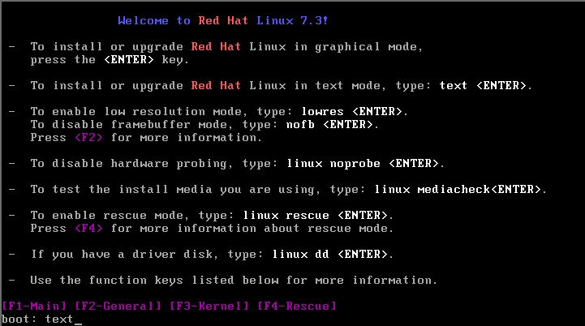
- Acknowledge the first banner page with an ok.

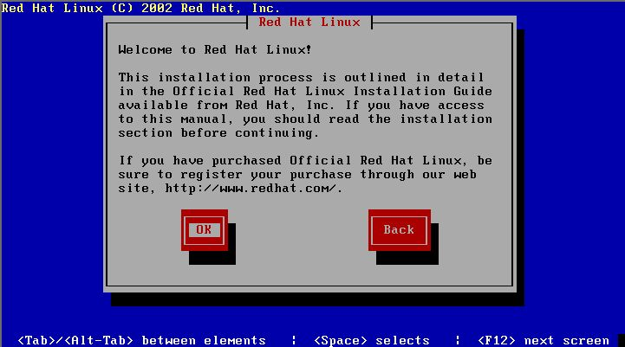

- Select the language that you will use. Tab to ok and enter.

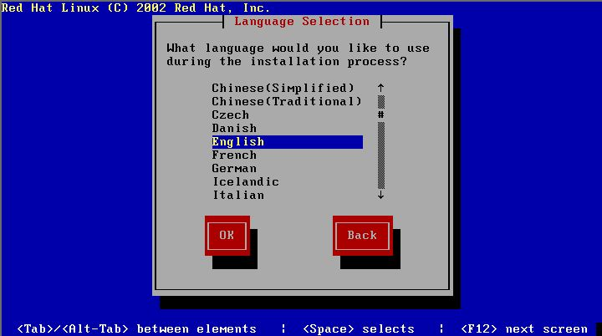
- Select the keyboard you will be using. Tab to ok and enter.

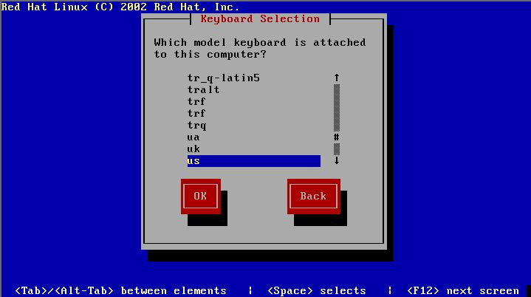

- Select the mouse you will be using. Tab to ok and enter.

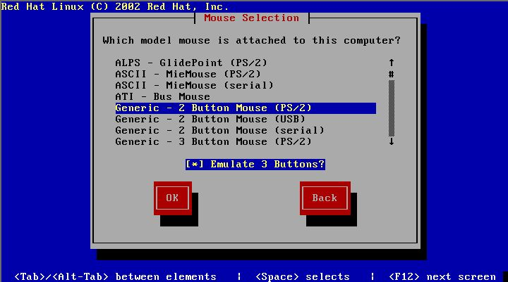
- Select LTSP as the system you are installing. Tab to ok and enter.

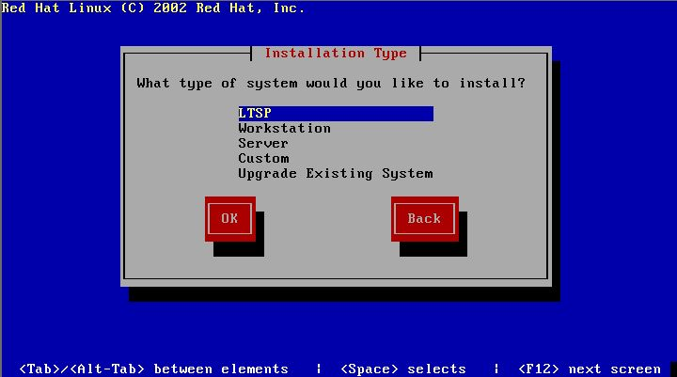

- For this install we are using the defaults. If you are familiar with Linux partitioning utilities you can pick your own partition tool.

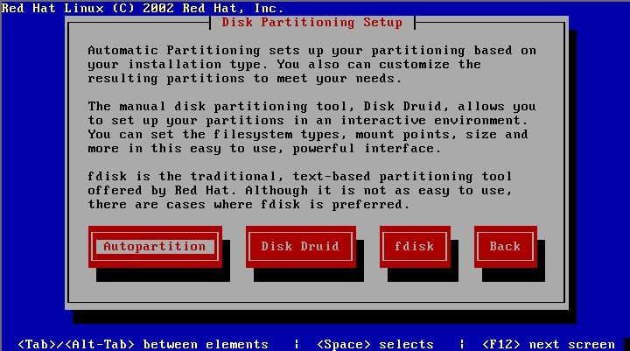
- If the drive on your system is new, you will encounter the following message. Press yes to continue on a new drive. The next two screens also deal with new drive information.

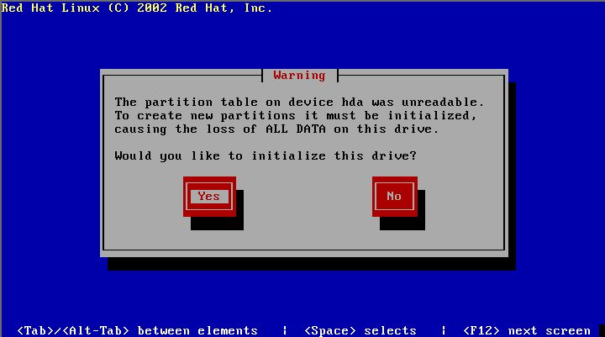

- This message again follows if we are installing on a new drive. Tab to ok and enter.

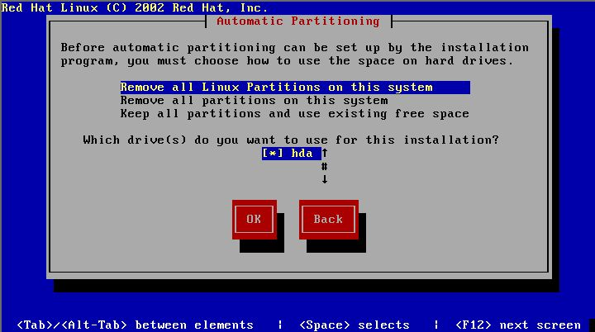
- Select yes if you are sure you want to install LTSP. Tab to yes and enter.

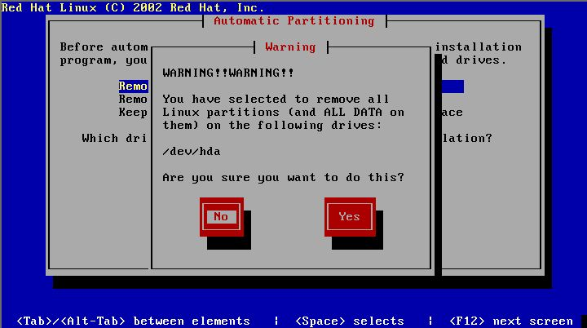

- This is the information from my autopartition of a 2gig drive. Your mileage may vary. Tab to ok and enter.

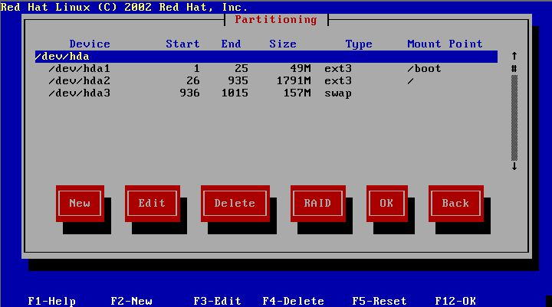
- This screen lets you choose your boot loader. I prefer lilo, but again for this install we are using the defaults. Select your boot loader, tab to ok and enter.

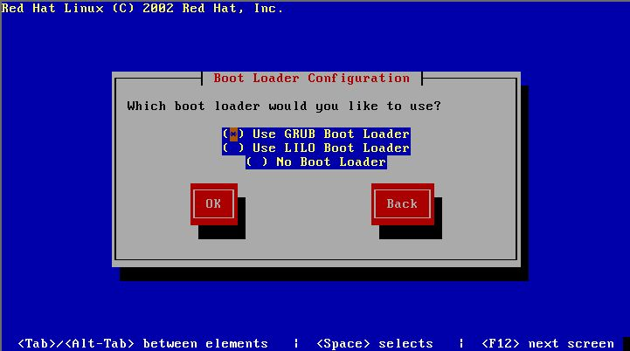

- Install the boot loader in the Master Boot Record. Tab to ok and enter.

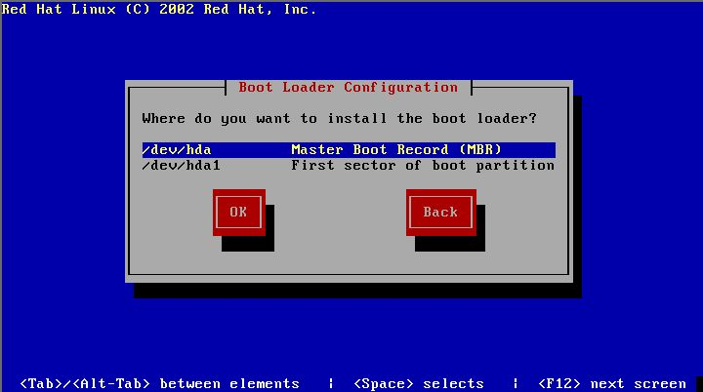
- Unless you have specific boot loader options this screen can be bypassed. Tab to ok and enter.

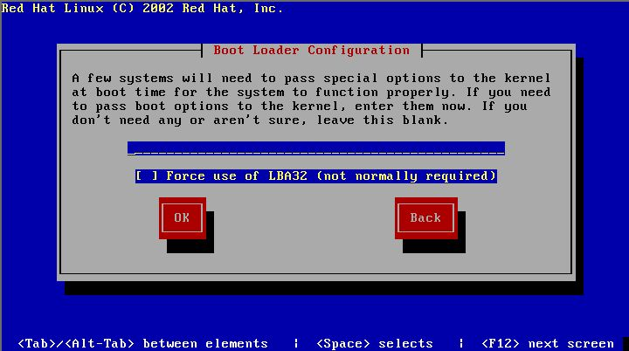

- Select the default operating system to boot. Tab to ok and enter.

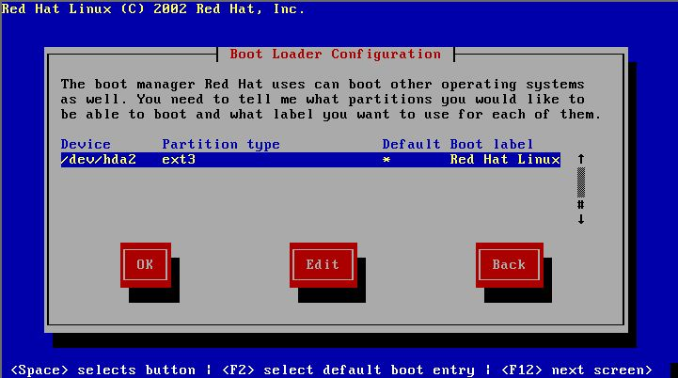
- This option will let you set a boot loader password. I always bypass this. Tab to ok and enter.

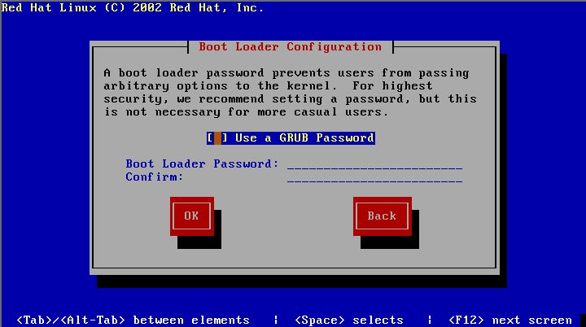

- This screen sets the TCP/IP address for this machine. You MUST use ALL the defaults here as the LTSP configuration files that will be installed are using these default addresses. If you want to make additional changes to your network, do them after you have a working cluster.

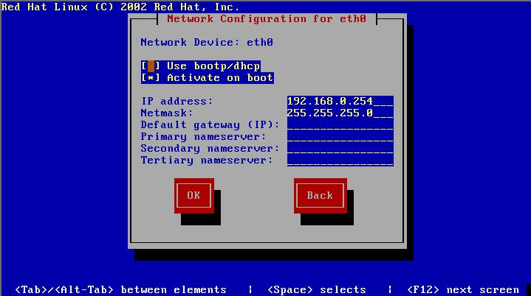
r. Continue down through the DEFAULTS, tab to ok and enter.

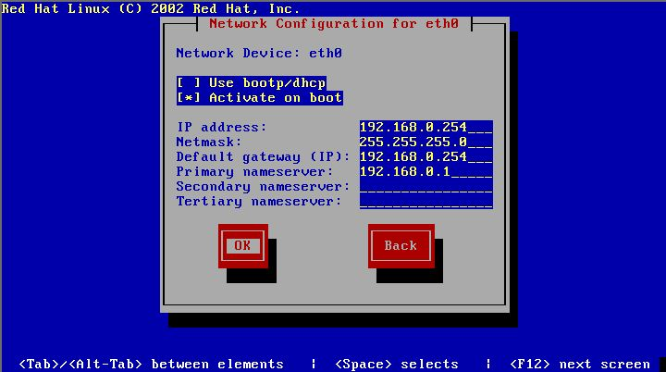

- Set the hostname for this machine to be “ltsp” only. If you place anything else here it will be changed to “ltsp” when the 2nd section of the installation runs.

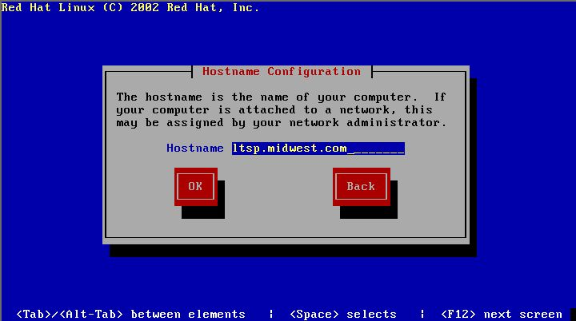
t. Setup your server to run as NO FIREWALL. Tab to ok and enter.

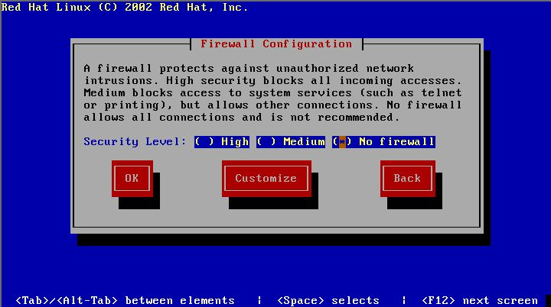

- Select any additional languages that you want on your server. Tab to ok and enter.

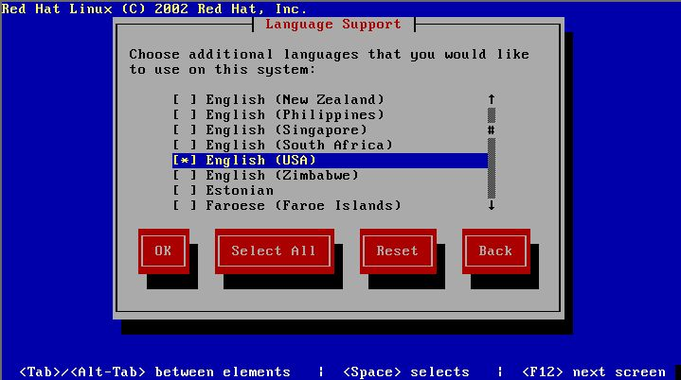
v. Select your time zone. Tab to ok and enter.

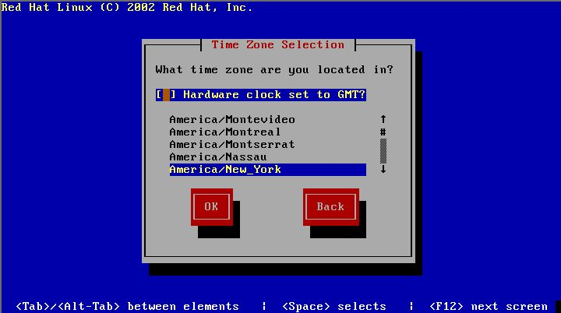

w. Choose a root password for the LTSP server. Tab to ok and enter.

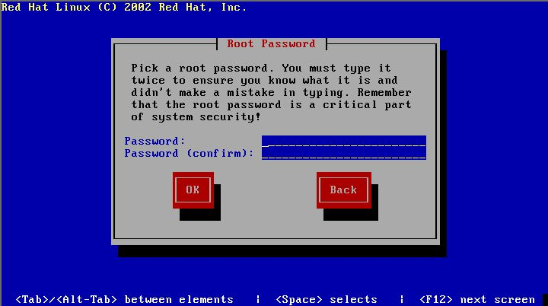
x. Setup at least one normal user account to log into. Tab to ok and enter.

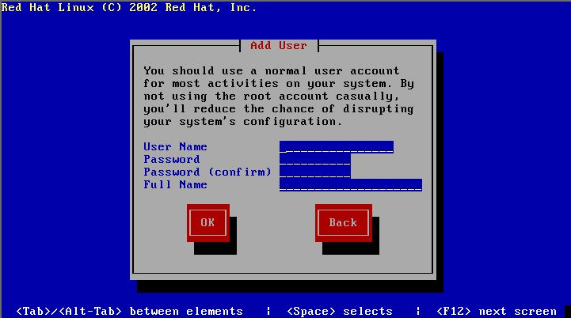

- Select the software packages you wish to install. You MUST select software development in order to install the mpi compiler. Tab to ok and enter.

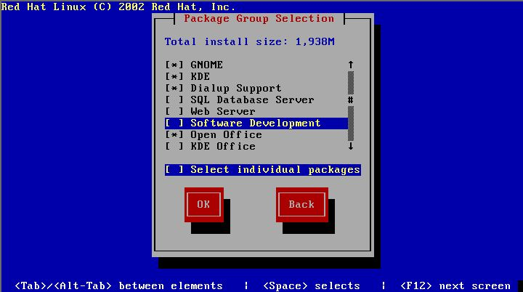
- The next section deals with the video card and monitor for the server. As my video card is not available in this installation, I do not have the following screens. Tab to ok and enter

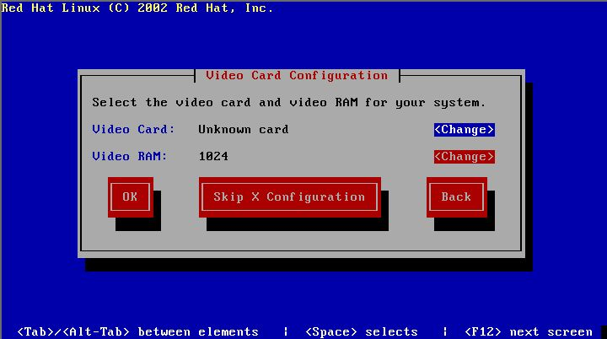

- The system will now install all of the selected components. Time for coffee and donuts.

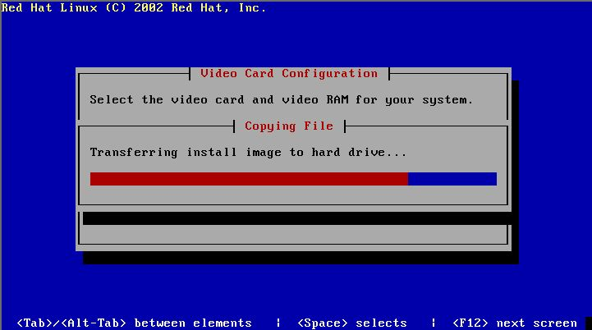
- Following the install, you can create a boot disk for your server. I always bypass this option.

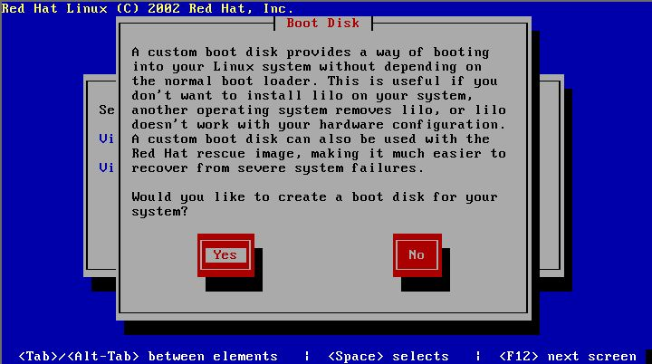

- This is the last screen of the basic Red Hat Linux 7.3 LTSP install.

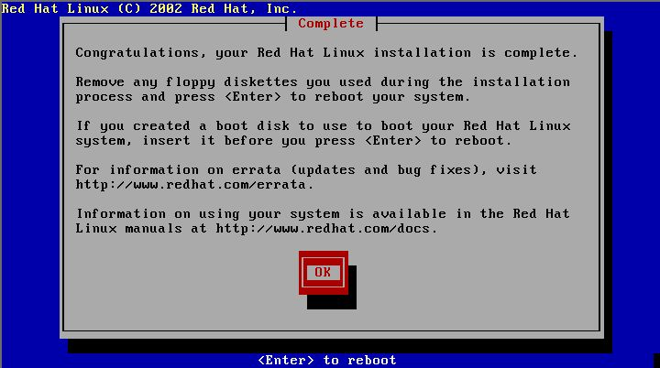
- The system will reboot and the third cd will be ejected.

- K12LTSP First Time Login

The initial login of your Red Hat 7.3 installation will require you to enter user preferences. As the author selected KDE as his default window manager, the screens that follow pertain specifically to KDE. Log into the LTSP server as the user you added during the install (NOT ROOT).

- Boot the newly installed LTSP server. During the boot process, insert the third cd from the HPC cluster workshop. This will be used to install the MPICH compiler.

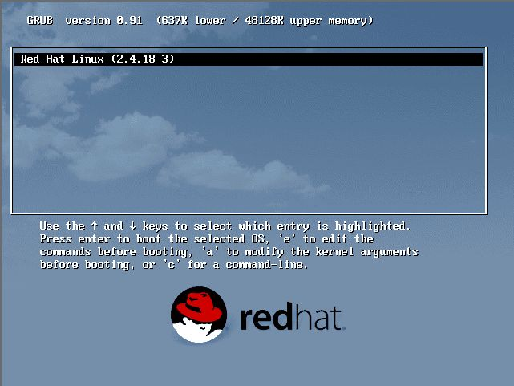

- After you log in, select your country and language. Select next to continue.

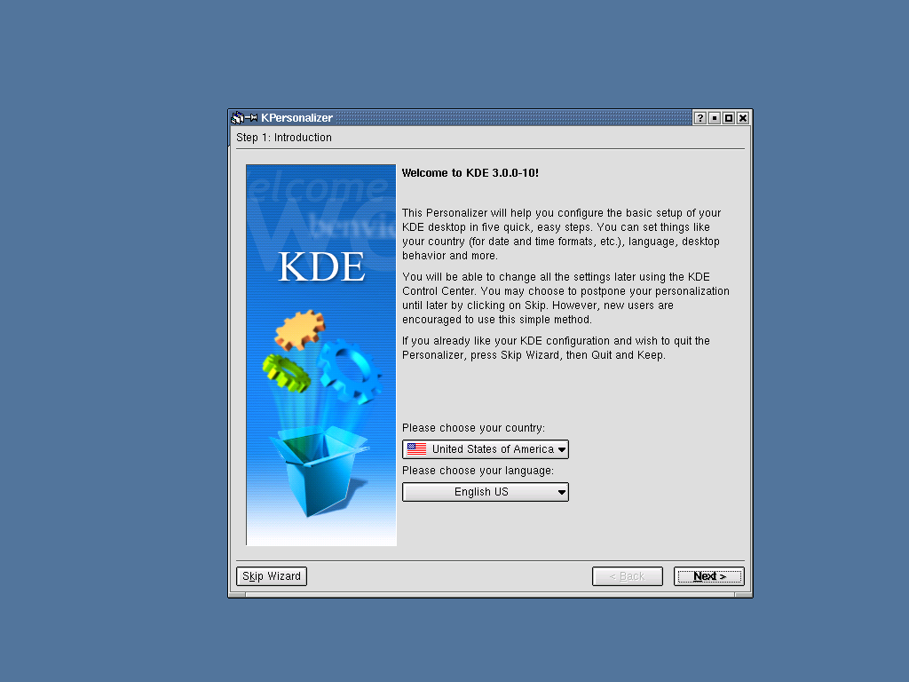

- Select your GUI system behavior. Select next to continue.

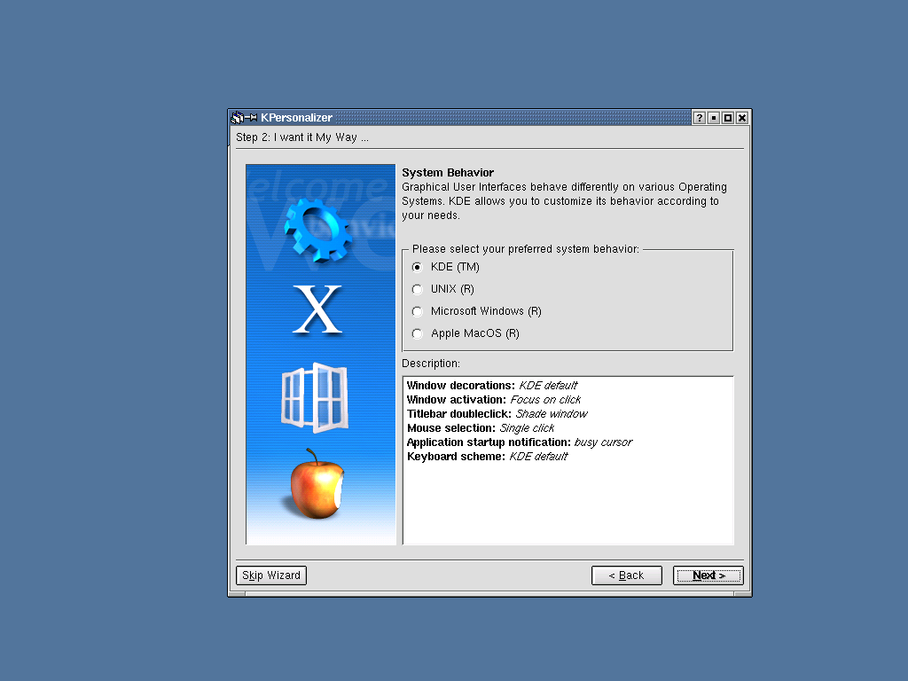

d. Select your GUI eye candy preferences. Select next to continue.

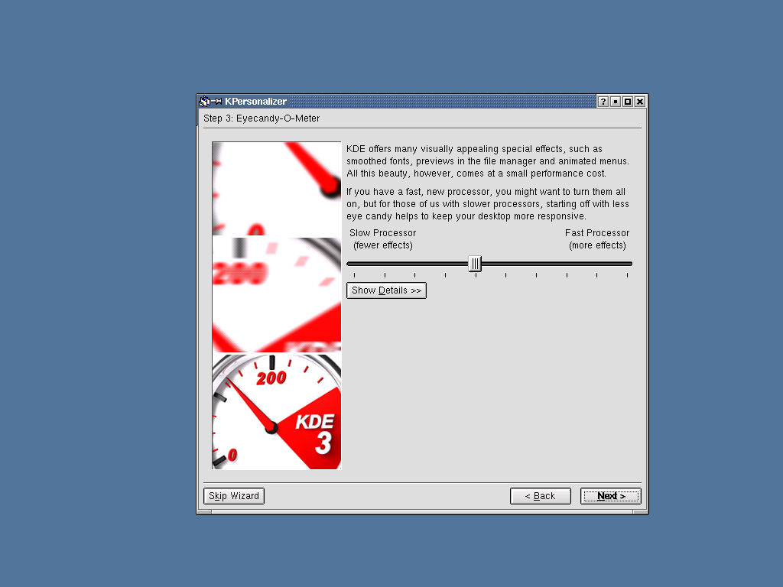

- Select your default theme preferences. Select next to continue.

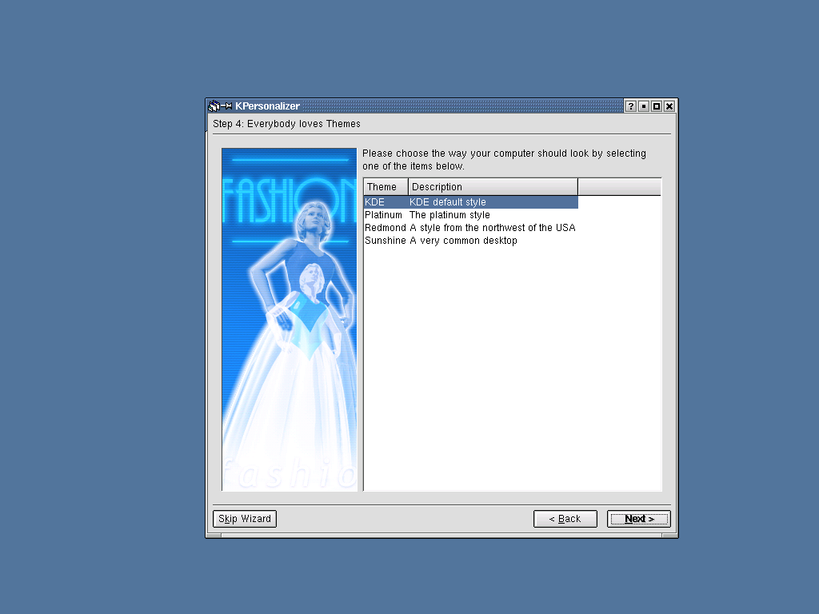

- Select your GUI panel preferences. Select next to continue.

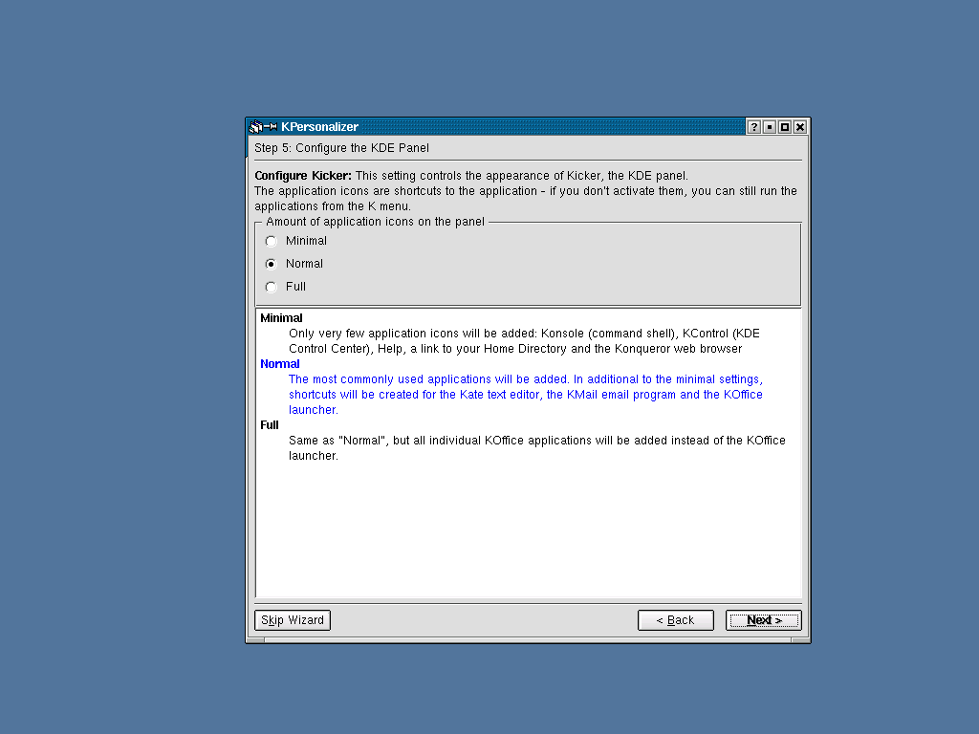

- Select finish to continue. Your window preferences are configured.

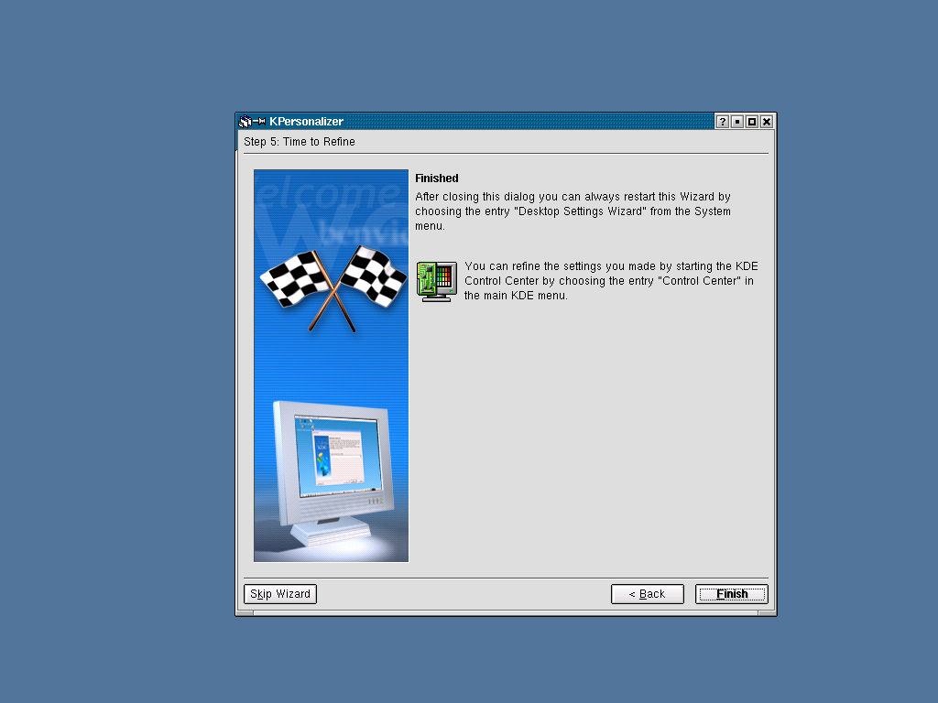

- This is your initial login screen once your preferences are finished.

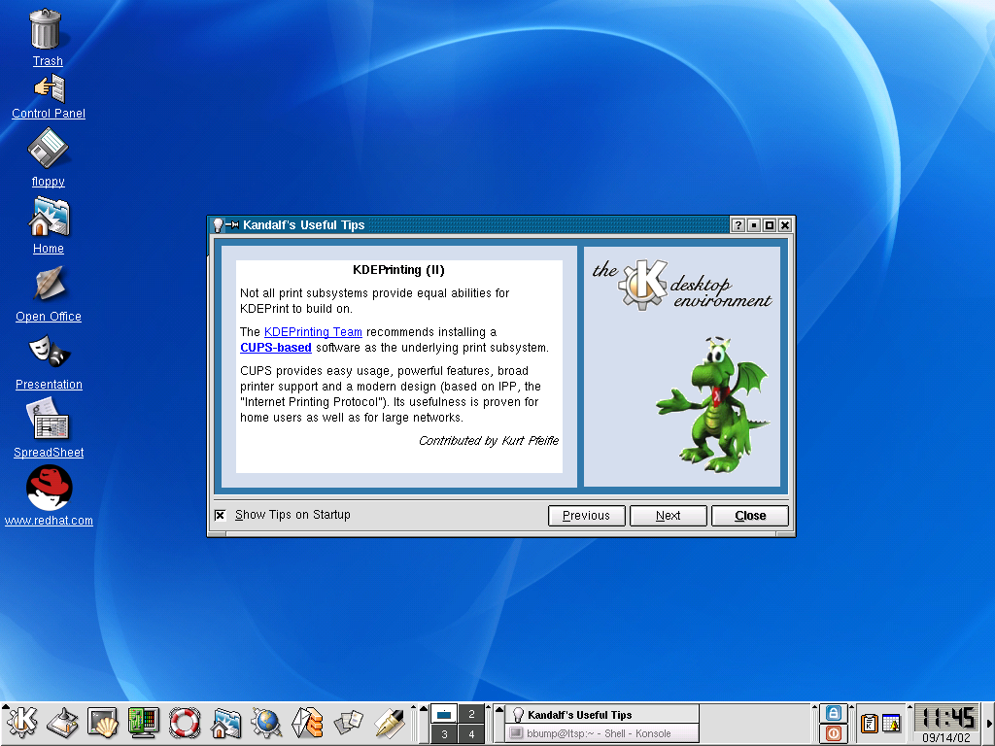

- MPICH Compiler Installation

The third disc in the Red Hat 7.3 LTSP distribution set had ample room remaining, that the author of this document decided to restamp this cd with additional files. The MPICH compiler and the system changes needed to combine LTSP and MPICH were included on this cd to streamline this process. If you do not have the third cd provided during the September 2002 HPC cluster workshop in Atlanta, you can obtain the MPICH compiler from: http://www-unix.mcs.anl.gov/mpi/mpich

- Log into the LTSP server as the user you added during the install (NOT ROOT). The third button on the task panel will bring up a command shell.

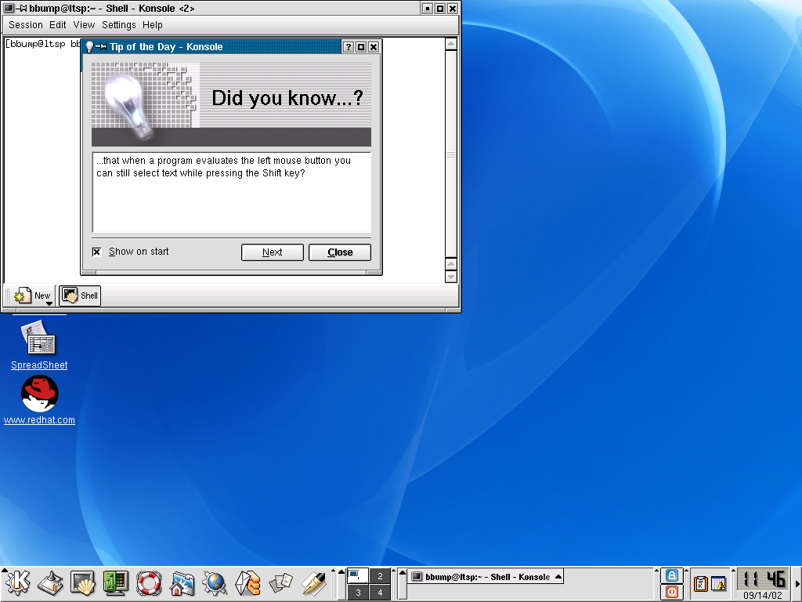

- With the third installation cd inserted, extract the MPICH compiler from the cd distribution with the following command:

$ tar –xzvf /mnt/cdrom/mpi/mpich.tgz

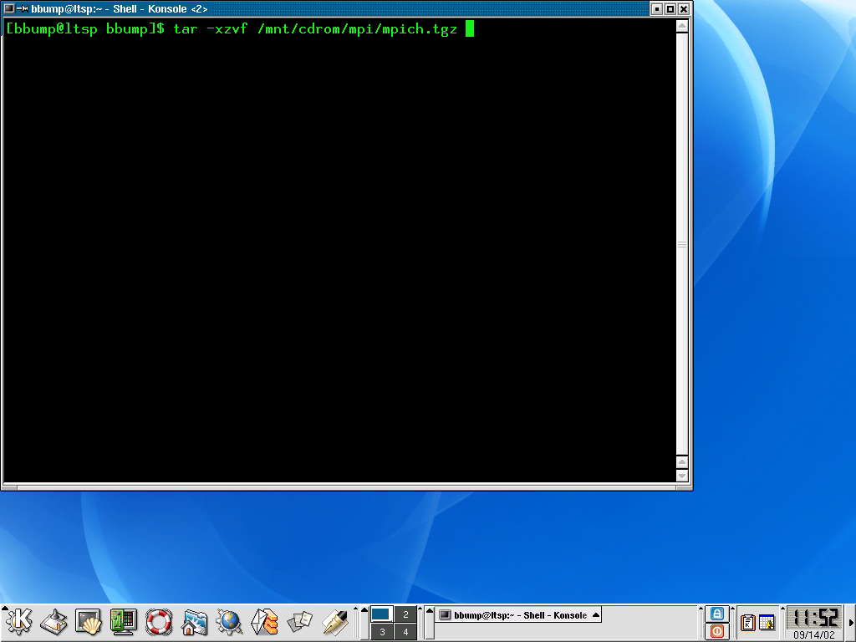

- Change your working directory to the location of the MPICH compiler source and run configure:

$ cd mpich-1.2.4/
$ ./configure

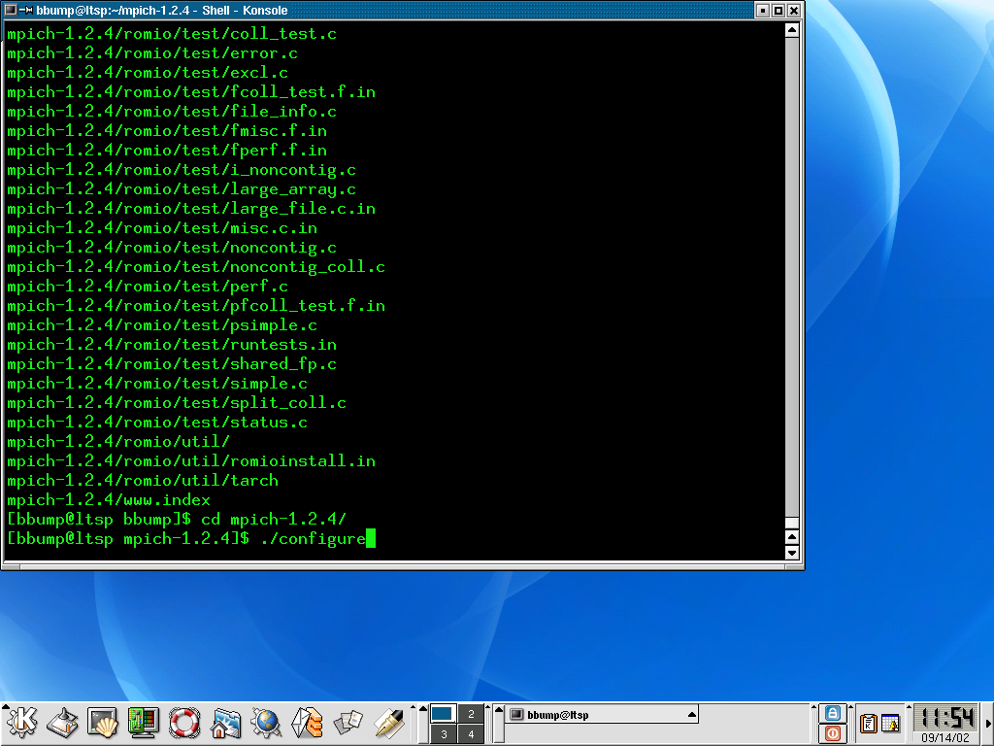

- Make the compiler in the current directory:

$ make

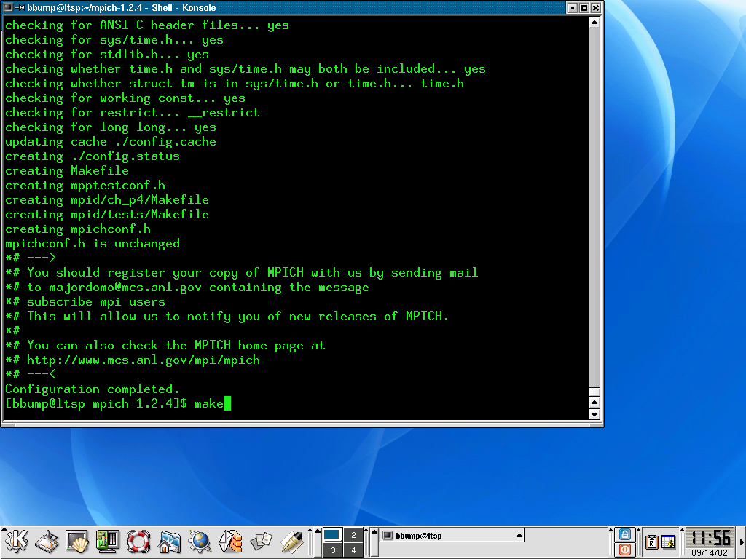

- Once the compiler is created, install it as root to a location on your system that users will have access to:

$ su
Password: ******
# ./bin/mpiinstall –prefix=/usr/local

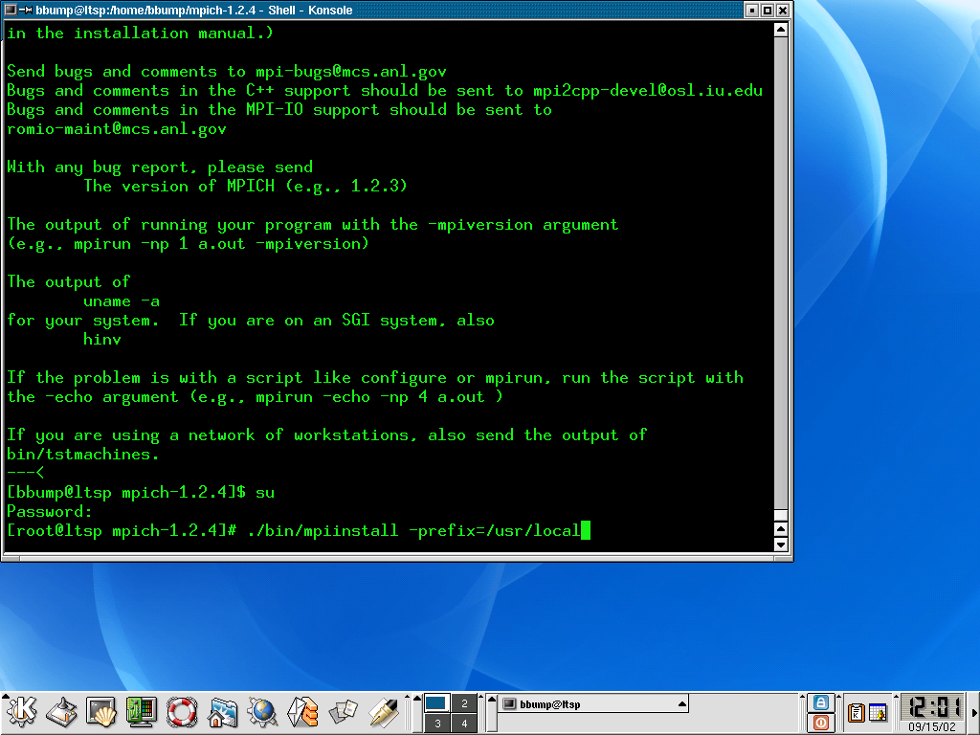

- Patch LTSP/MPI and setup Yellow Pages

LTSP in the default form is designed to let workstations netboot Linux from the LTS server and use it’s resources for all of the work. The workstation’s cpu however remains relatively unused. If we change LTS to let these workstations run local applications, we can remotely run MPICH applications.

- Continue from the MPICH compiler install as root and setup the ltsp domainname. Install the LTSP, MPI and Yellow Pages support files as root, from the root directory:

# cd /
# domanname ltsp
# tar –xzvf /mnt/cdrom/mpi/mpilts.tgz

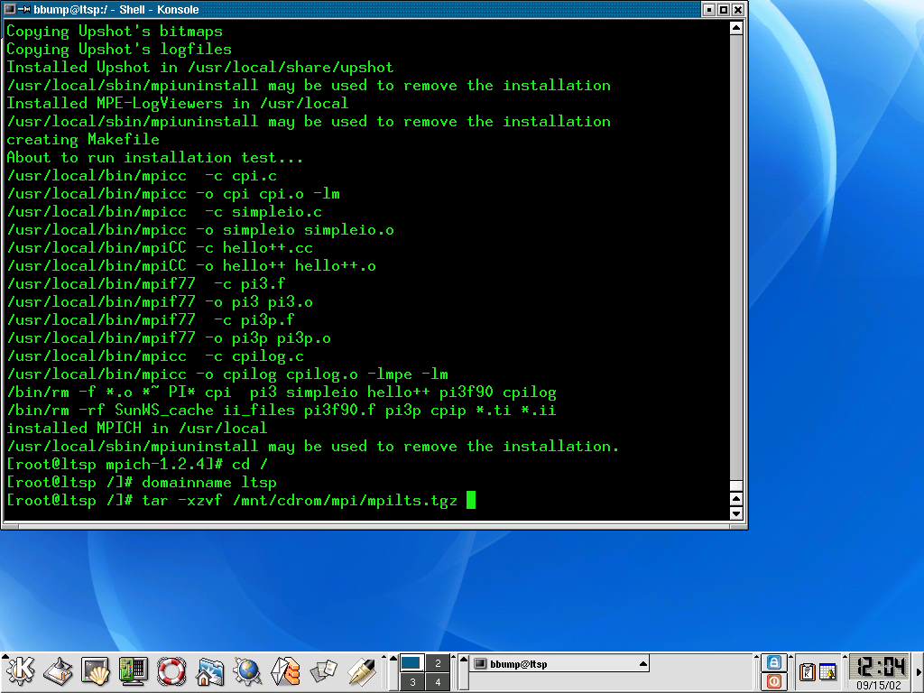

- Start and save the yppasswdd and ypservd services.

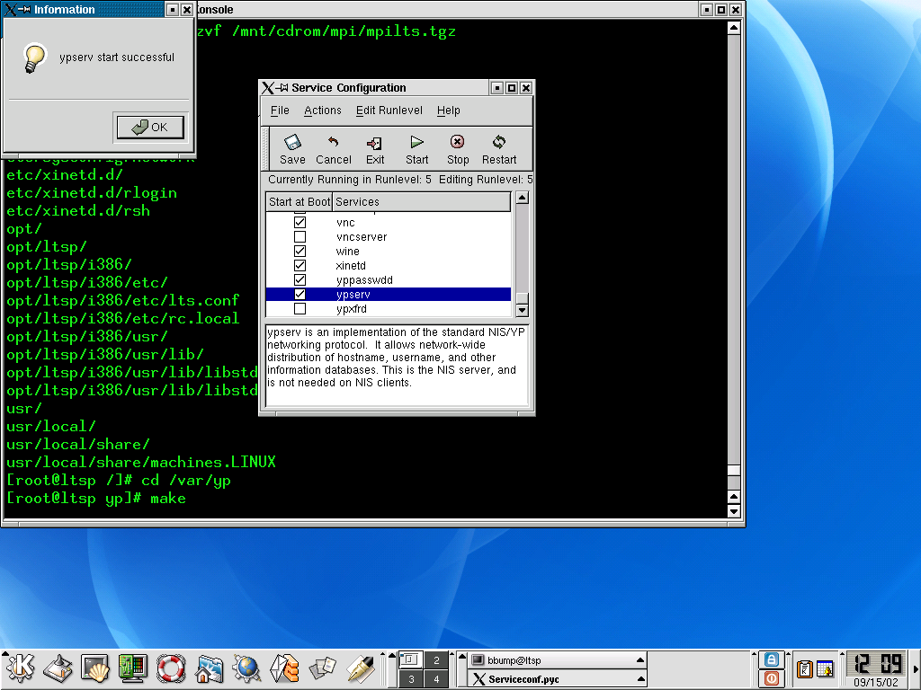

- With the ypserv daemon running, create the Yellow Pages database:

# cd /var/yp
# make

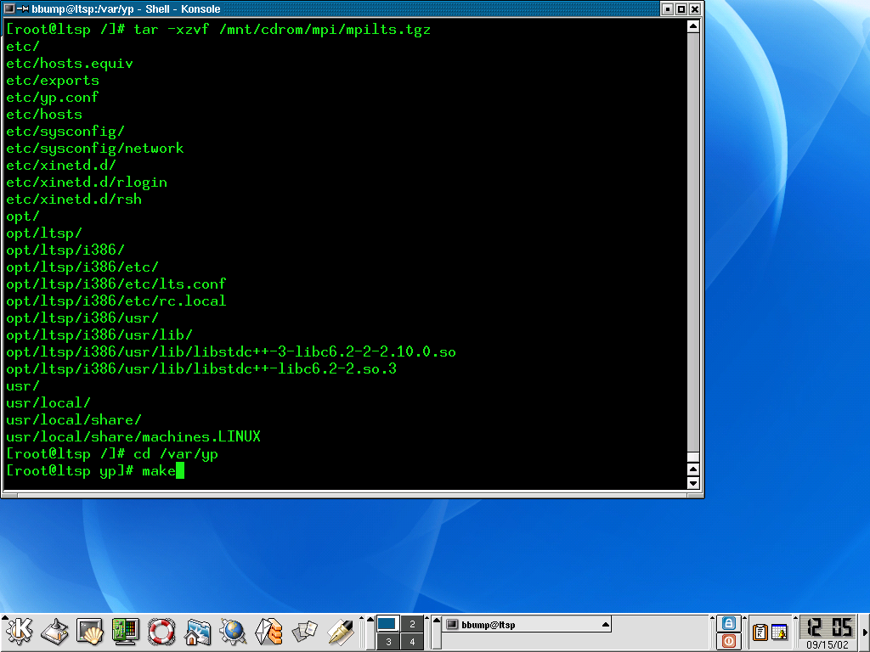

- With Yellow Pages updated, exit the root and user shells, exit KDE and reboot the LTSP server. The server is now configured for running cluster applications.

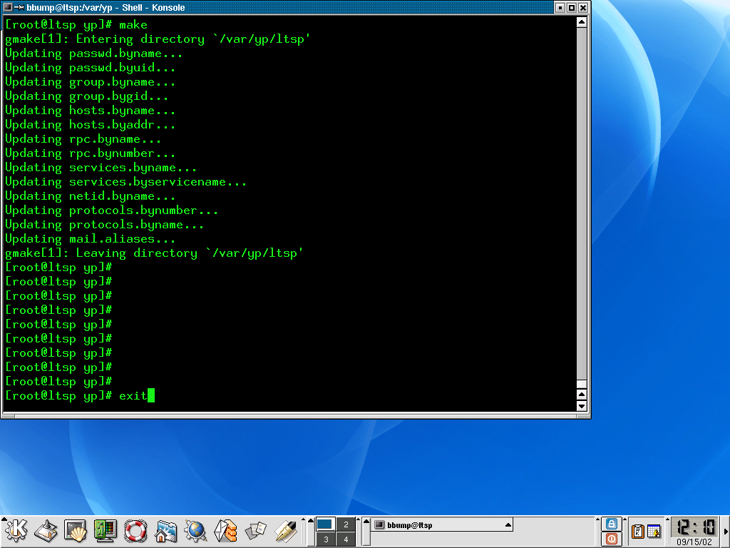

- Testing your cluster server

- Boot the cluster server. Again, the third disc contains cluster utilities you can load.

- Extract and make the GalaxSee program written by David Joiner:

$ tar –xzvf /mnt/cdrom/mpi/Gal.tgz
$ cd Gal
$ make

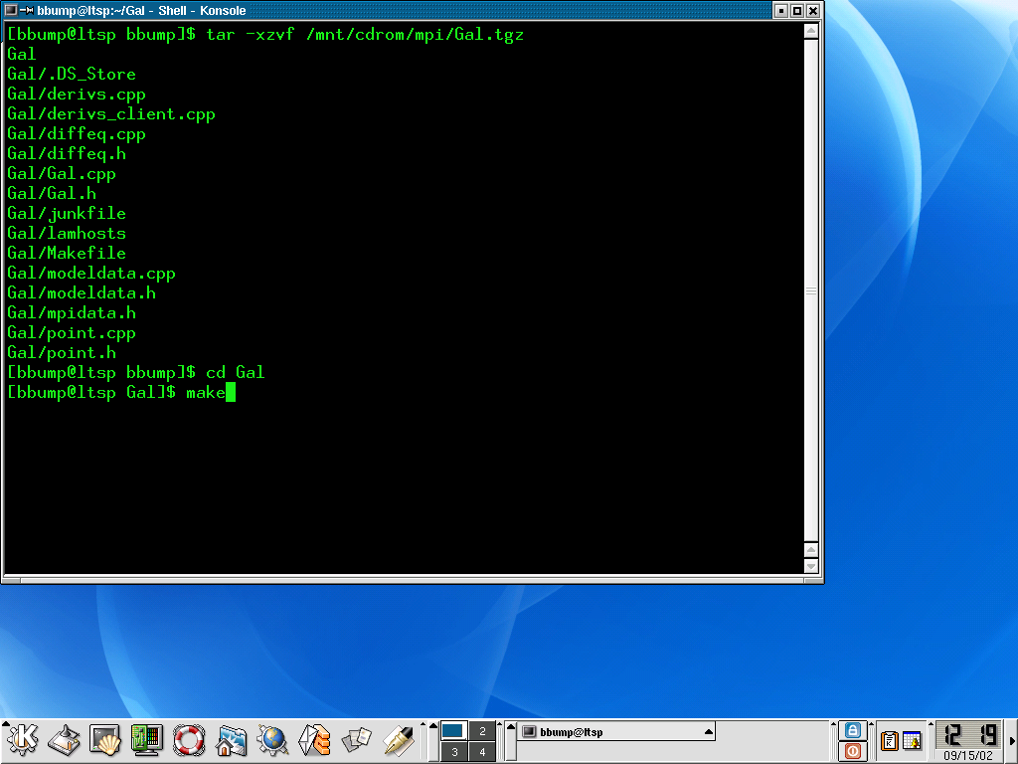

- Run the GalaxSee application:

$ mpirun –np 2 GalaxSee

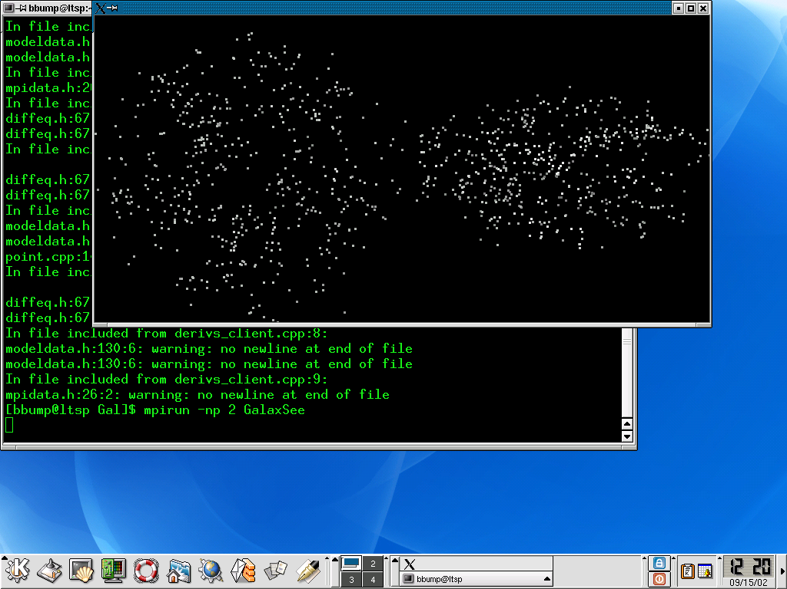

Conclusion

The example cluster in this tutorial was created and installed on two Compaq Pentium III computers running at 700mhz. The user that attempts this installation should note that the author left the default setup for netbooted workstations to boot run level 5 (X11). This configuration is handy for the students in a classroom however the network demand can become HUGE very quickly. If the user decides to use all of the computers in a classroom to demonstrate a cluster application, it would be best if the default option for run level in /opt/ltsp/i386/etc/lts.conf be changed from 5 to 3.

